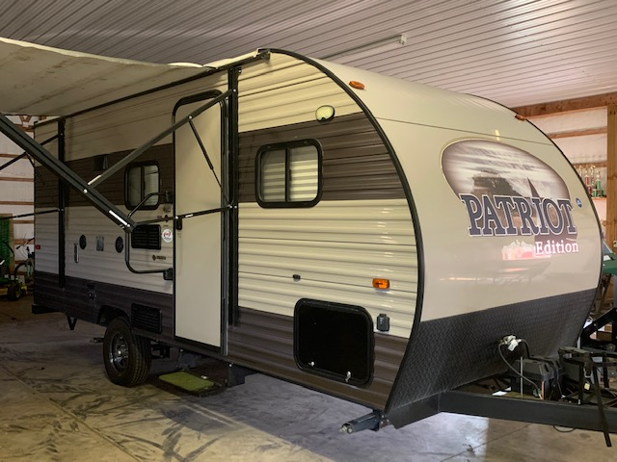 |  | WElcome to the Patriot!  2018 Forest River 16BHS
Patriot  2018 Forest River Patriot Edition 16BHS  Sleep 5  Outdoor Speakers  USB ports for charging  Power Jack  Power Awning  A/C  And so much more!  G & R Works, Llc  Owner/operators Greg and Ryan Gaebel. We have several rental properties and now camper rental!  If you come across something you have a question on, please don’t hesitate to reach out!  Contact  PHONE:  218-329-1821 (Text response is fastest)  EMAIL:  Gabes403@gmail.com  Table of contents  Inventory  Operating Instructions  Return Instructions  Your Documents |  | Inclusions  Linens  Sheets are provided for each bed.  Bath/Shower towels are provided for 5.  Kitchen towels and a washcloth are provided.  Kitchen  Pots, pans, utensils, measuring cups and a place setting for 5 are available. All dishes should be washed and returned to their spot before the camper is returned.  REMINDERS  Lights  The dome lights operate by pushing the button on the center of the dome. There is not a master switch.  Toilet  Only use the supplied toilet paper. If you need to buy more, it must be RV/Marine toilet paper. Using any other will clog the pipe/toilet and you will lose the deposit. The toilet has a foot pedal to flush.  Grey Water  While the camper sleeps 5, be mindful of your water usage. A longer trip with multiple showers may result in a full grey tank faster.  Jacks  Make sure you have leveled and put all 4 jacks down in order to properly stabilize your camper. There is a balance level on the hitch.  Weather  Pay attention to the weather in your camping area. If there will be strong winds, the awning should be rolled up. An awning is costly to replace.

